6 | - Display empno, ename, deptno from employee table. Instead of display department numbers display the related department name (Use decode function).  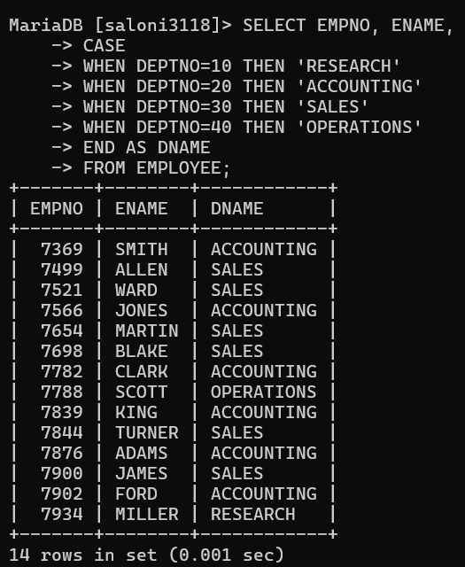  - Display your age in days.  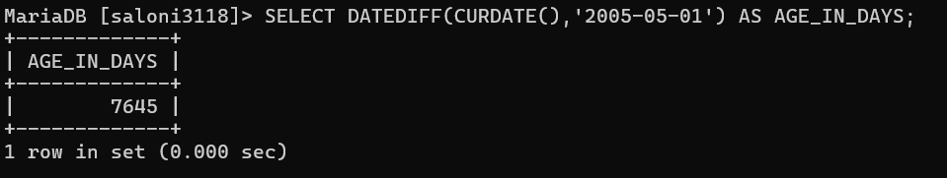  - Display your age in months.  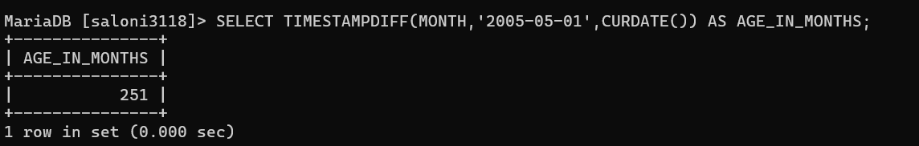  - Display the current date as 15th August Friday Nineteen Ninety-Seven.  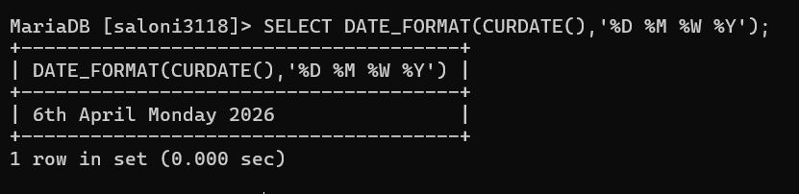  - Display the following output for each row from employee table.  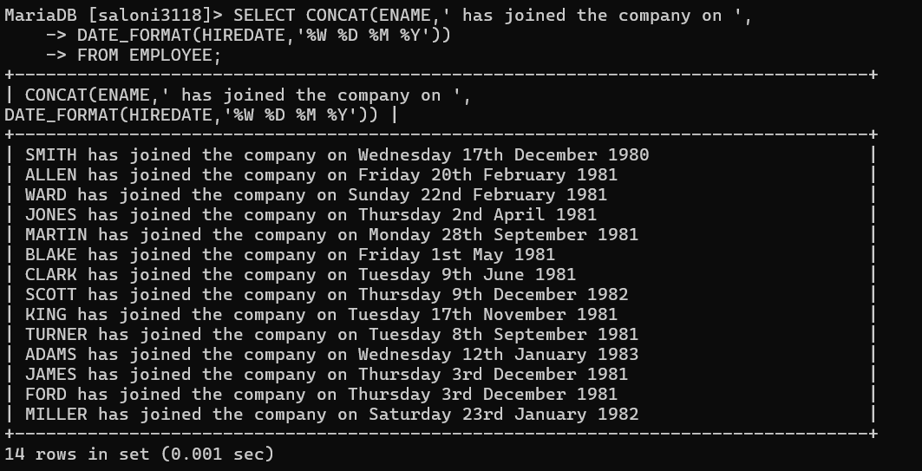  - Scott has joined the company on Wednesday 13th August Nineteen Ninety  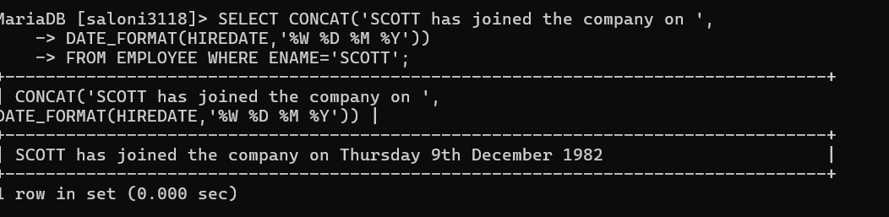  - Find the date for nearest Saturday after current date.  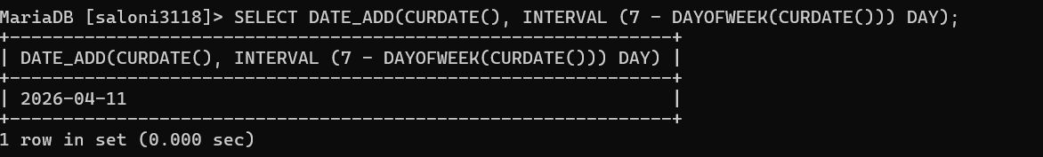  - Display current time.  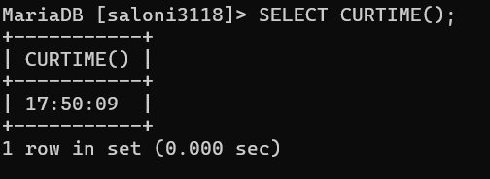  - Display the date three months Before the current date  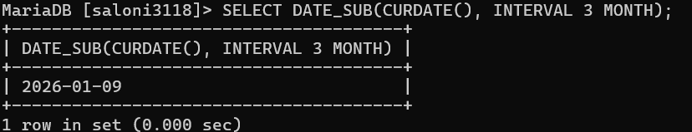  - Display those employees who joined in the company in the month of Dec.  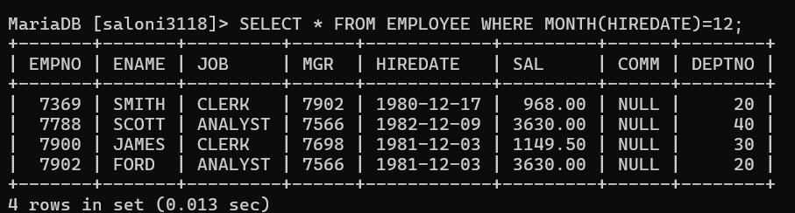  - Display those employees whose first 2 characters from hire date -last 2 characters of salary.  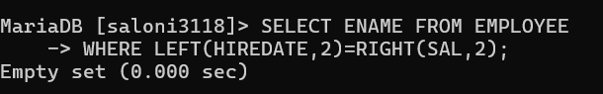  - Display those employees whose 10% of salary is equal to the year of joining.  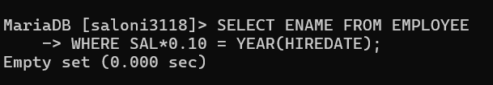  - Display those employees who joined the company before 15 of the months.  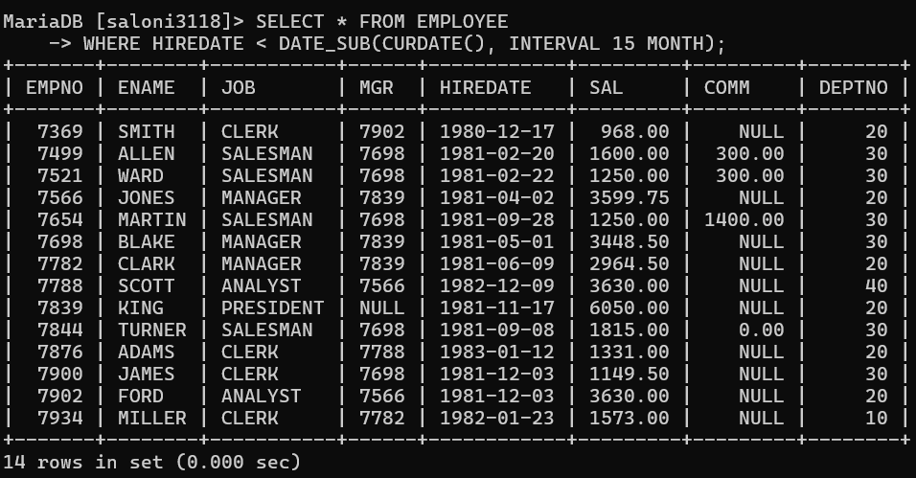  - Display those employees who has joined before 15th of the month  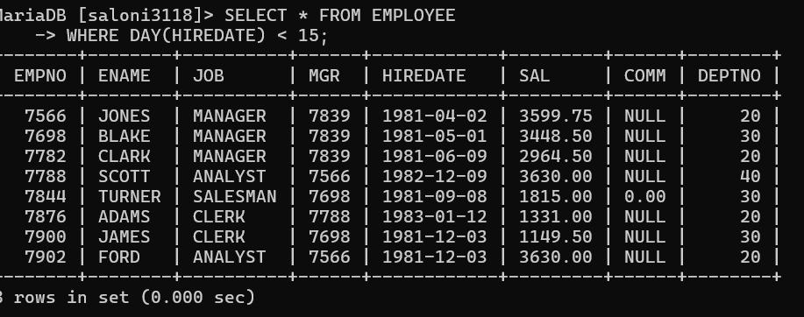  - Display those employees whose joining DATE is available in deptno  